**Exercise 3: Implementing the Builder Pattern**

**Output:**

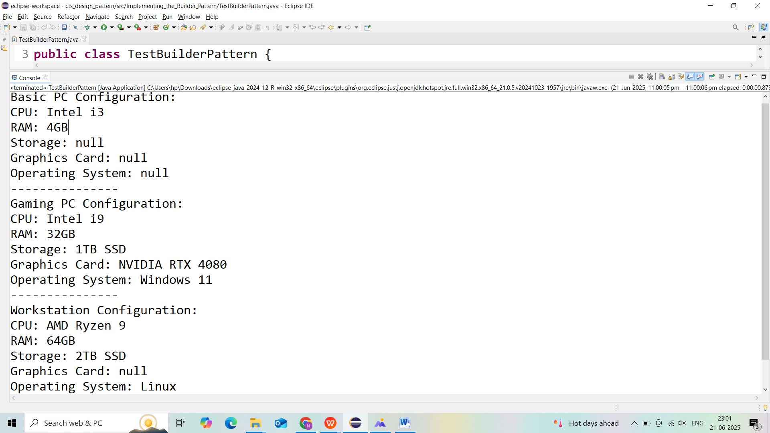

**Exercise 4: Implementing the Adapter Pattern**

**Output:**

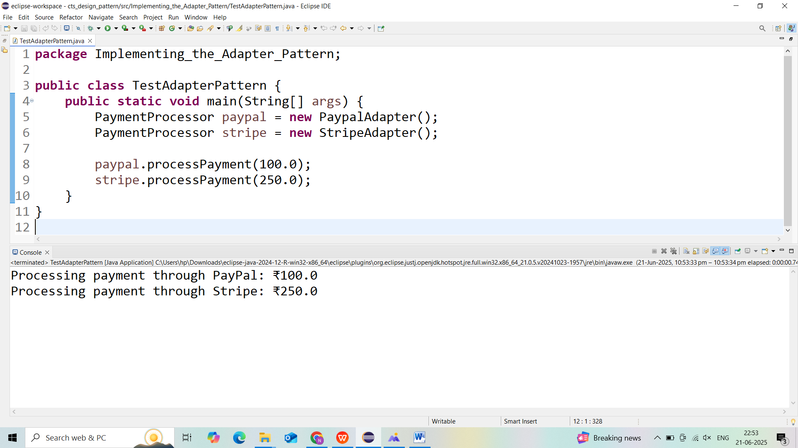

**Exercise 5: Implementing the Decorator Pattern**

**Output:**

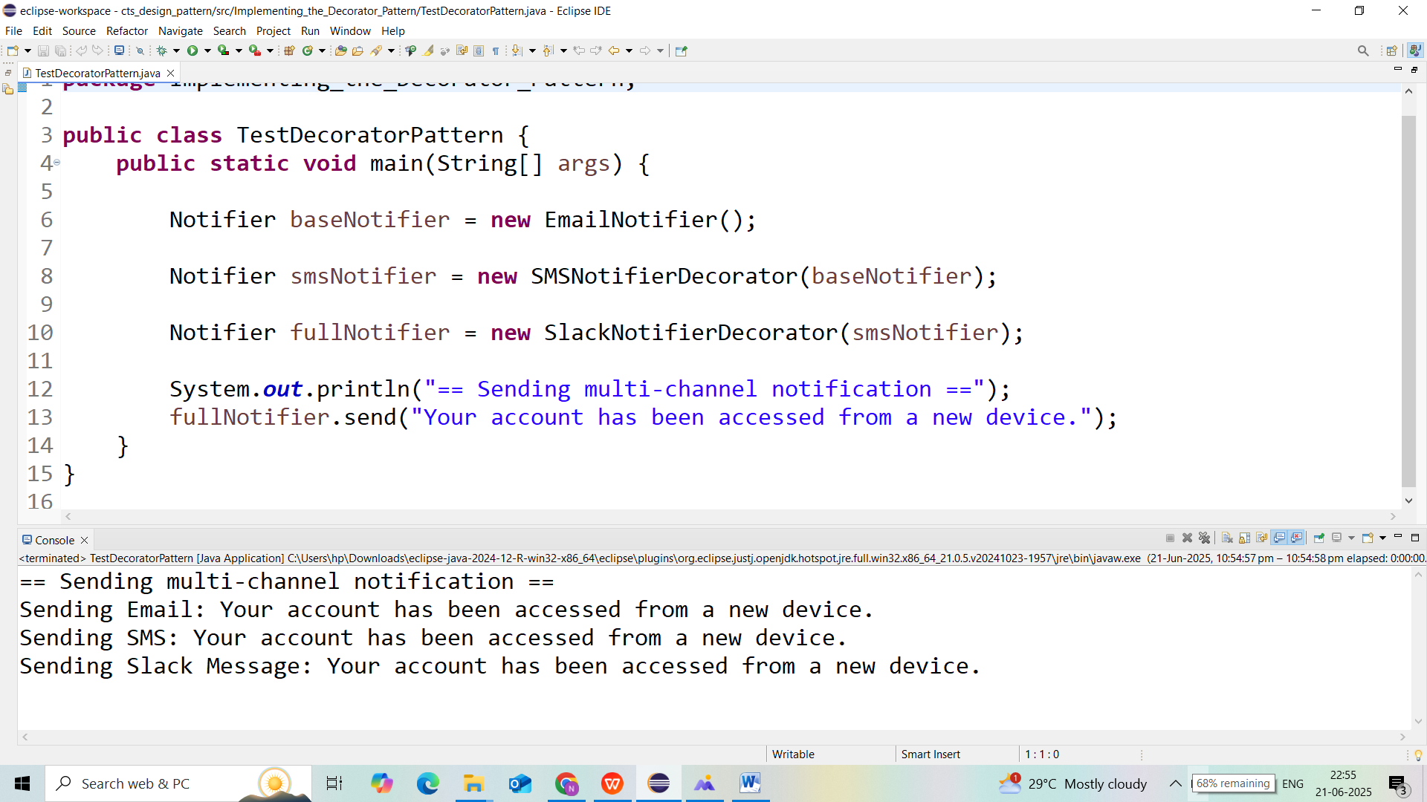

**Exercise 6: Implementing the Proxy Pattern**

**Output:**

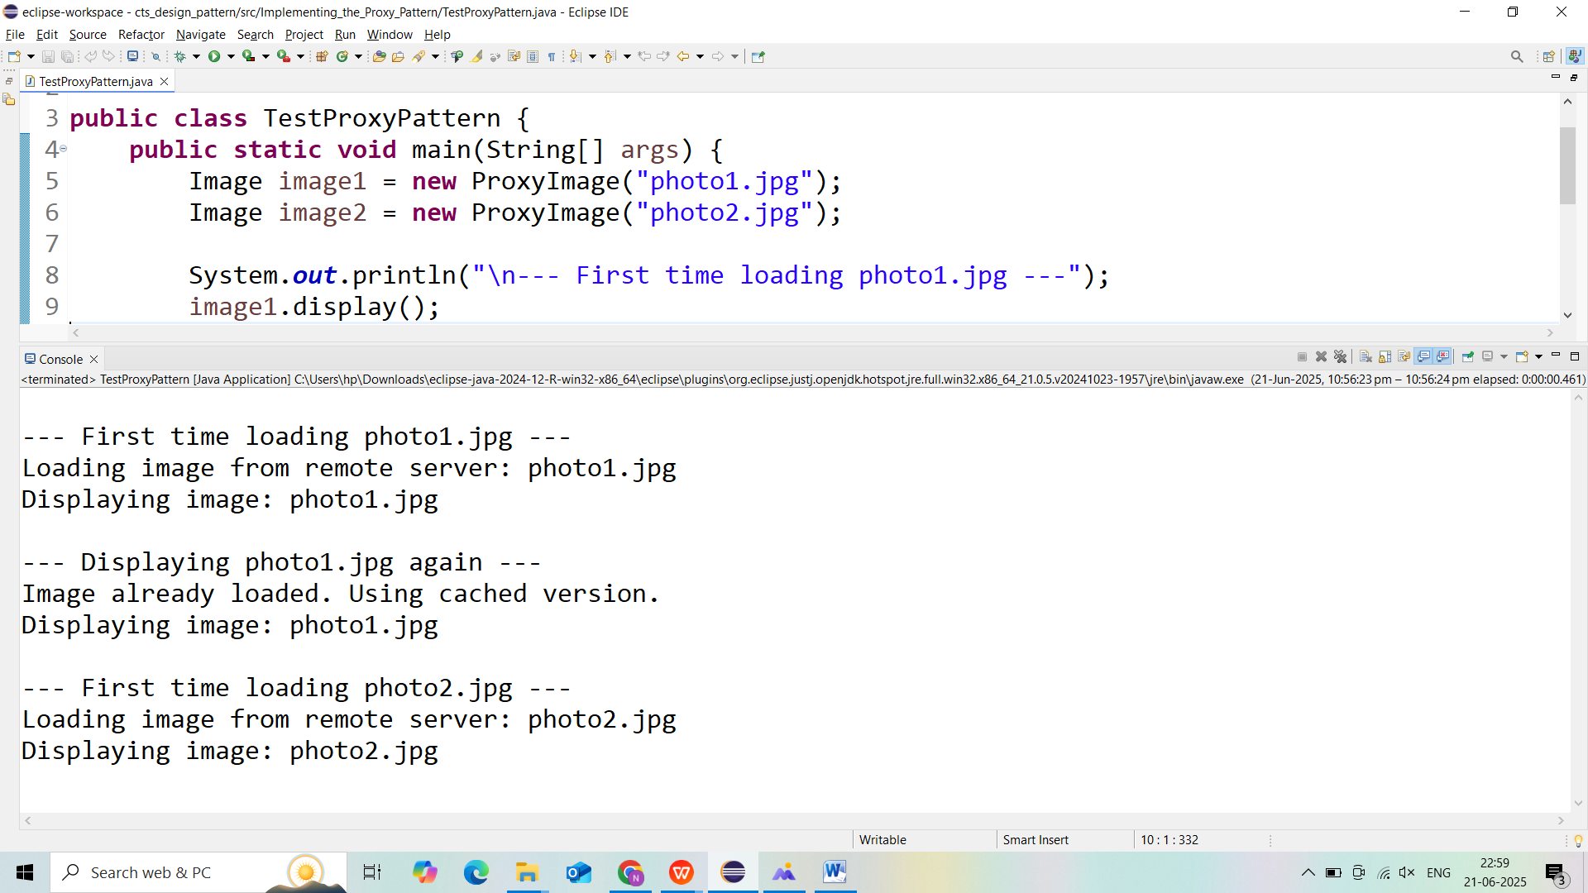

**Exercise 7: Implementing the Observer Pattern**

**Output:**

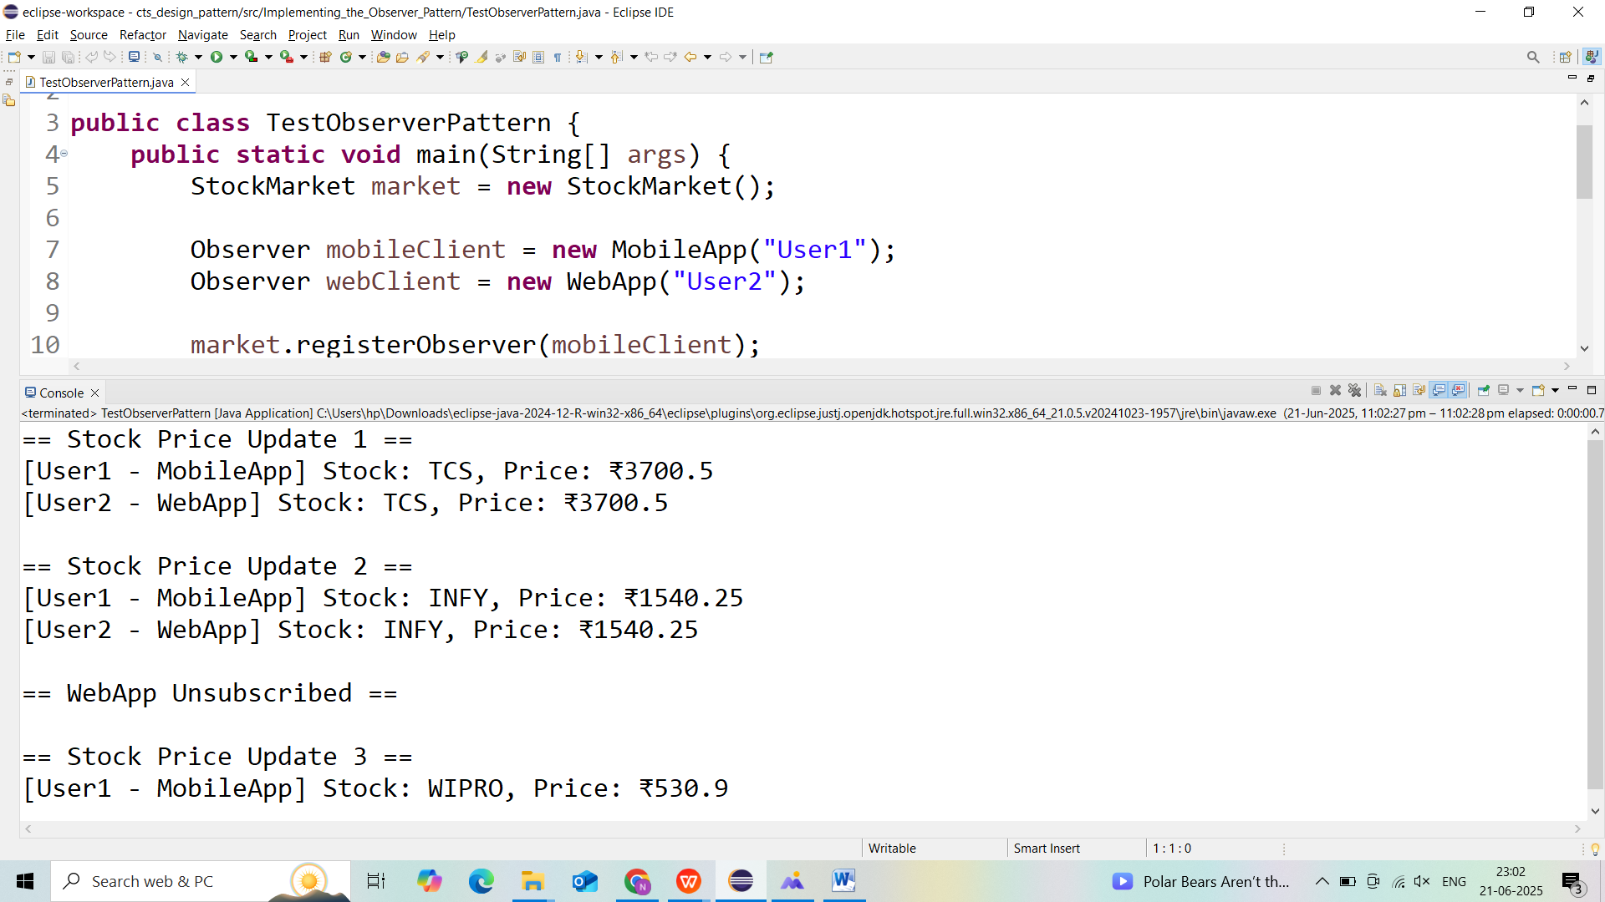

**Exercise 8: Implementing the Strategy Pattern**

**Output:**

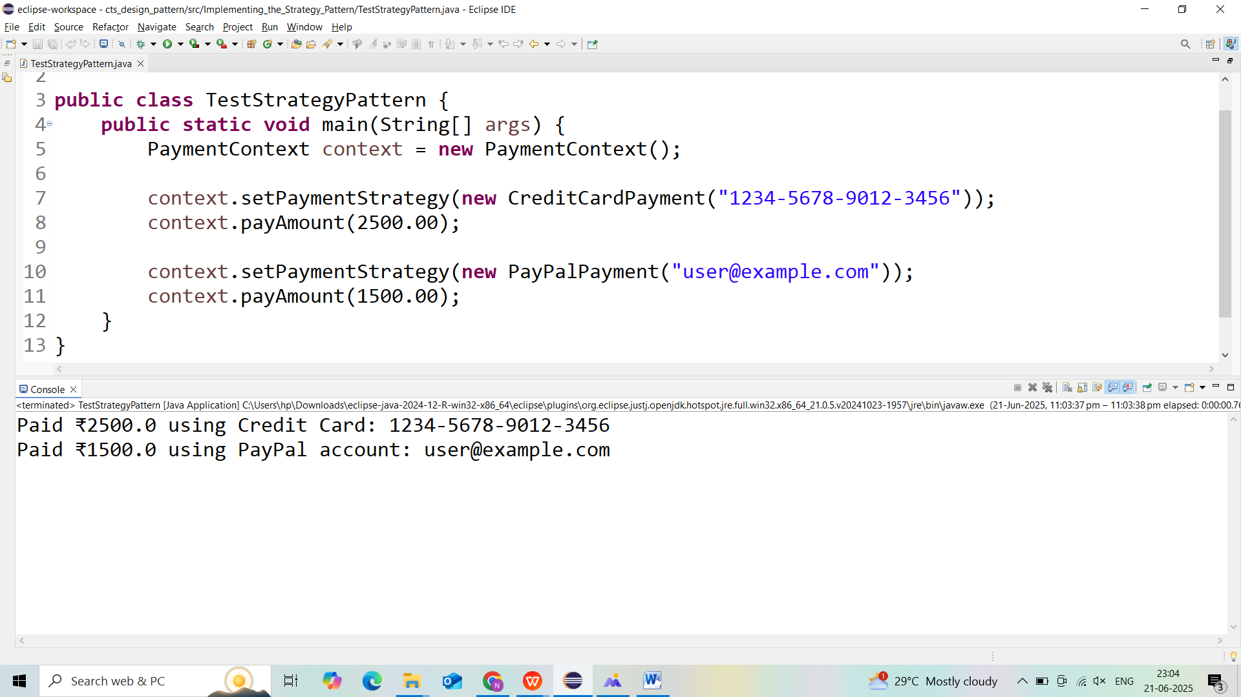

**Exercise 9: Implementing the Command Pattern**

**Output:**

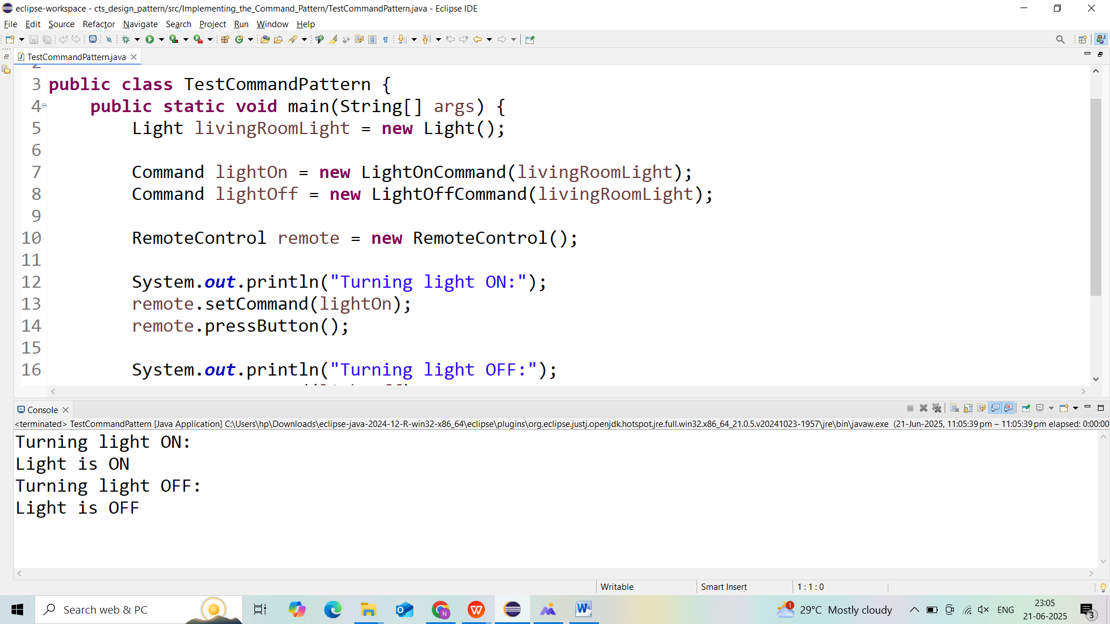

**Exercise 10: Implementing the MVC Pattern**

**Output:**

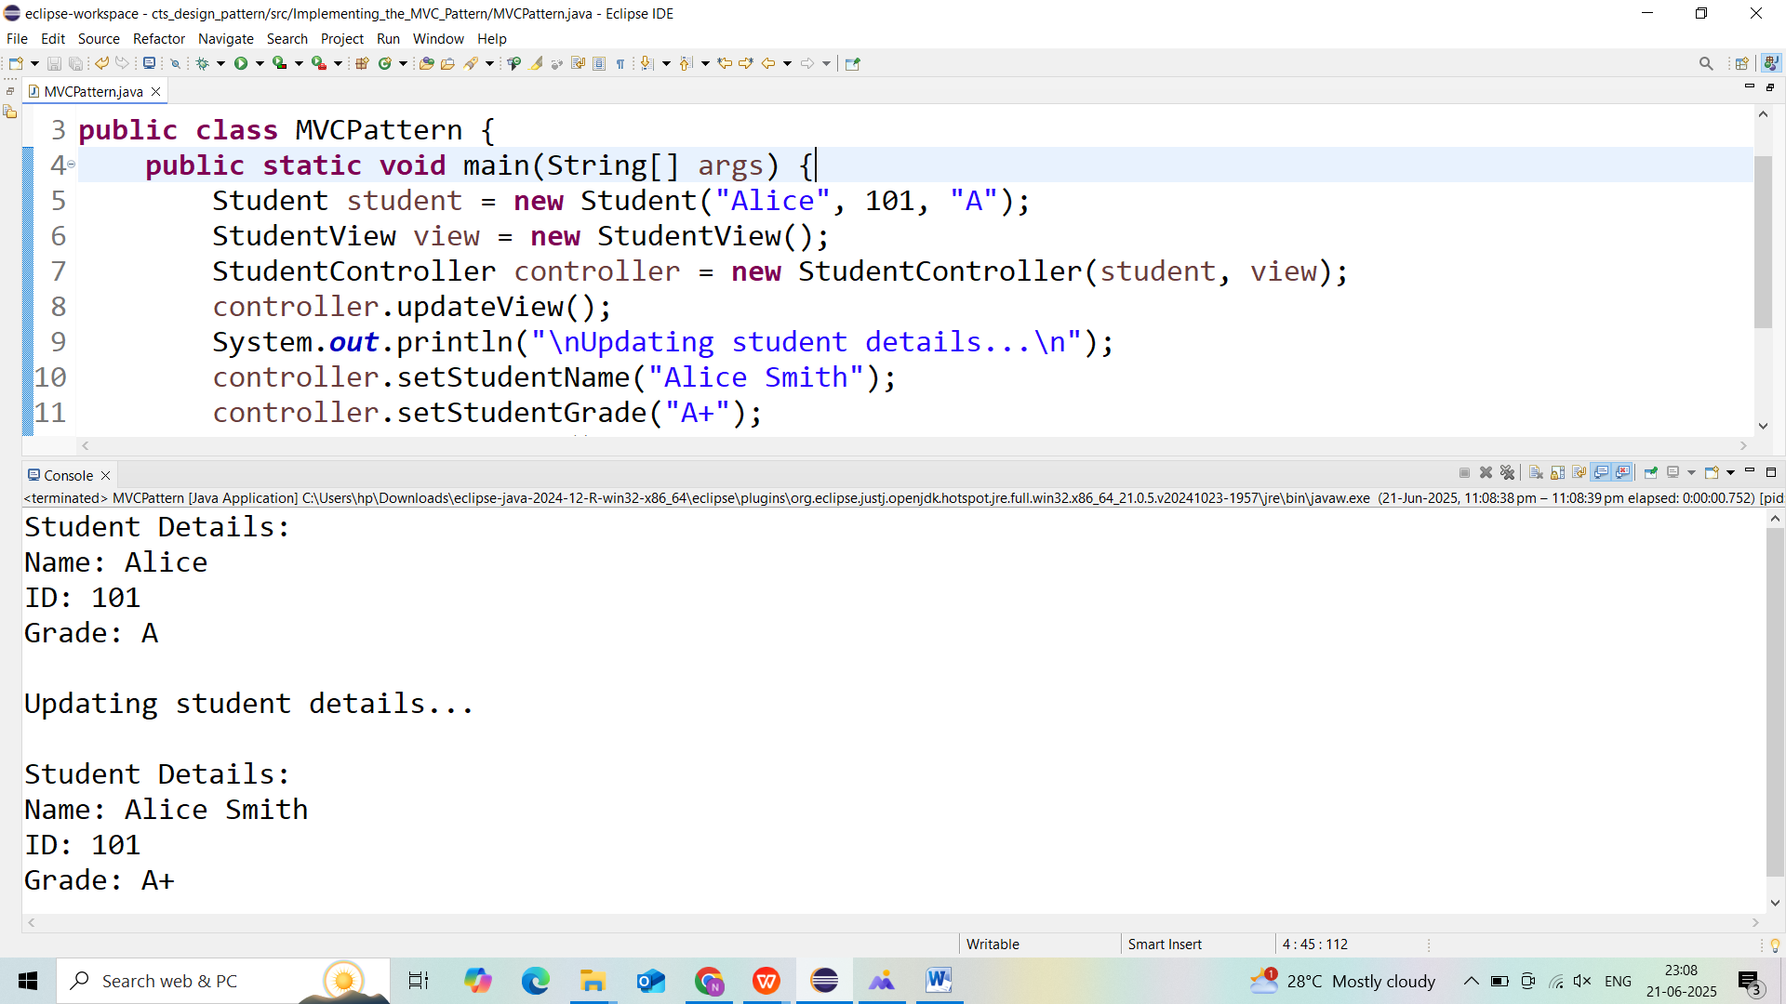

**Exercise 11: Implementing Dependency Injection**

**Output:**

